Point on a Line

Definition
# Source: AI Source: Provided by: [Data Path: Persons Table -> ID Column: 1, Name_En Column: Motasem Essam] -> From: [ChatGPT] on [7/25/2026]
Point on a Line is a type of Point Containment in which a point lies on an infinite straight line.
If point P lies on line l, the relationship is written as:
$$\boxed{P∈l}$$
This means that P is one of the points that make up line l.
A line contains infinitely many points, and a point on the line can be located anywhere along its infinite extent.
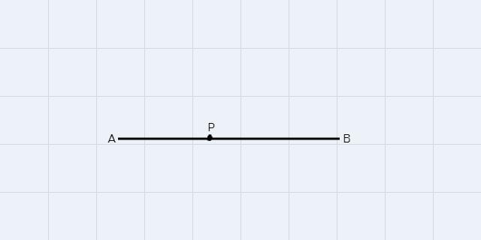
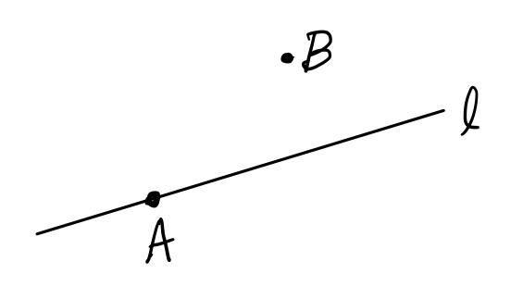
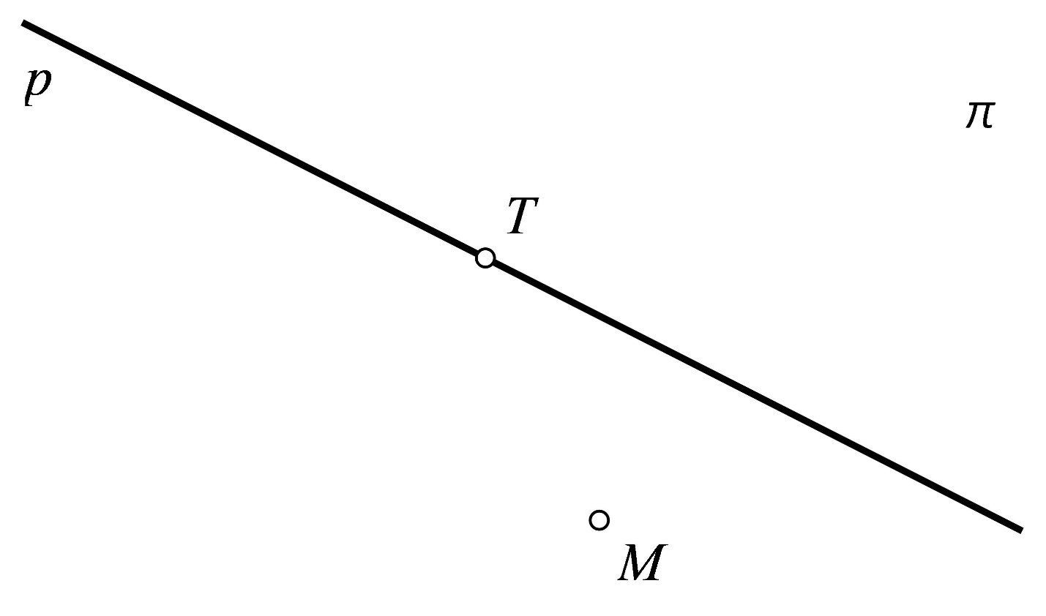

Purpose
# Source: AI Source: Provided by: [Data Path: Persons Table -> ID Column: 1, Name_En Column: Motasem Essam] -> From: [ChatGPT] on [7/25/2026]
The concept of a point on a line is used to:
- Determine whether a point belongs to a given line.
- Define the position of points in relation to lines.
- Establish geometric relationships between points and lines.
- Define line segments and rays.
- Solve coordinate-geometry problems.
- Verify whether coordinates satisfy a line equation.
- Construct and analyze geometric figures.

Fundamental Concept
# Source: AI Source: Provided by: [Data Path: Persons Table -> ID Column: 1, Name_En Column: Motasem Essam] -> From: [ChatGPT] on [7/25/2026]
A line can be considered as a set of infinitely many points.
If:
$$l=\left\{P∣P\text{ satisfies the equation of }l\right\}$$
then:
$$P∈l$$
means that point P satisfies the condition defining the line.
For example:
$$l:y=2x+1$$
contains points such as:
$$\left(0 , 1\right), \left(1 , 3\right), \left(2 , 5\right), \left(- , 1-1\right)$$
because each point satisfies:
$$y=2x+1$$

Mathematical Representation
# Source: AI Source: Provided by: [Data Path: Persons Table -> ID Column: 1, Name_En Column: Motasem Essam] -> From: [ChatGPT] on [7/25/2026]
The basic notation is:
$$\boxed{P∈l}$$
where:
- P = point
- l = line
- \in = "is an element of" or "belongs to"
If the point does not lie on the line:
$$\boxed{P∉l}$$

Point on a Line in Coordinate Geometry
# Source: AI Source: Provided by: [Data Path: Persons Table -> ID Column: 1, Name_En Column: Motasem Essam] -> From: [ChatGPT] on [7/25/2026]
Cartesian Equation
A line in the plane can commonly be represented by:
$$ax+by=c$$
For a point:
$$P=\left(x_{0} , y_{0}\right)$$
the point lies on the line if:
$$\boxed{ax_{0}+by_{0}=c}$$
If this equality is true, the point is on the line.

Example 1 – Point on a Line
# Source: AI Source: Provided by: [Data Path: Persons Table -> ID Column: 1, Name_En Column: Motasem Essam] -> From: [ChatGPT] on [7/25/2026]
Determine whether:
$$P=\left(3 , 7\right)$$
lies on:
$$y=2x+1$$
Substitute:
$$x=3, y=7$$
into the equation:
$$7=2\left(3\right)+1 \\ 7=7$$
Therefore:
$$\boxed{P∈l}$$
The point lies on the line.

Example 2 – Point Not on a Line
# Source: AI Source: Provided by: [Data Path: Persons Table -> ID Column: 1, Name_En Column: Motasem Essam] -> From: [ChatGPT] on [7/25/2026]
Determine whether:
$$P=\left(3 , 8\right)$$
lies on:
$$y=2x+1$$
Substitute:
$$8=2\left(3\right)+1 \\ 8=7$$
This is false.
Therefore:
$$\boxed{P∉l}$$
The point does not lie on the line.

Point on a Vertical Line
# Source: AI Source: Provided by: [Data Path: Persons Table -> ID Column: 1, Name_En Column: Motasem Essam] -> From: [ChatGPT] on [7/25/2026]
A vertical line has an equation of the form:
$$x=a$$
For example:
$$x=4$$
A point:
$$P=\left(4 , 10\right)$$
lies on the line because its x-coordinate is 4.
$$\boxed{P∈l}$$
But:
$$Q=\left(3 , 10\right)$$
does not lie on it:
$$\boxed{Q∉l}$$

Point on a Horizontal Line
# Source: AI Source: Provided by: [Data Path: Persons Table -> ID Column: 1, Name_En Column: Motasem Essam] -> From: [ChatGPT] on [7/25/2026]
A horizontal line has an equation of the form:
$$y=b$$
For example:
$$y=5$$
A point:
$$P=\left(10 , 5\right)$$
lies on the line:
$$\boxed{P∈l}$$
because its y-coordinate is 5.

Point on a Line Using the Slope-Intercept Form
# Source: AI Source: Provided by: [Data Path: Persons Table -> ID Column: 1, Name_En Column: Motasem Essam] -> From: [ChatGPT] on [7/25/2026]
A non-vertical line can be represented as:
$$y=mx+b$$
where:
- m = slope
- b = y-intercept.
A point:
$$P=\left(x_{0} , y_{0}\right)$$
lies on the line if:
$$\boxed{y_{0}=mx_{0}+b}$$
Example
Line:
$$y=3x-2$$
Point:
$$P=\left(2 , 4\right)$$
Check:
$$4=3\left(2\right)-2 \\ 4=6-2 \\ 4=4$$
Therefore:
$$\boxed{P∈l}$$

Point on a Line Using Two Points
# Source: AI Source: Provided by: [Data Path: Persons Table -> ID Column: 1, Name_En Column: Motasem Essam] -> From: [ChatGPT] on [7/25/2026]
A line can be determined by two distinct points.
Suppose:
$$A=\left(1 , 2\right)$$
and:
$$B=\left(4 , 8\right)$$
The slope is:
$$m=\frac{8-2}{4-1} \\ m=\frac{6}{3}=2$$
Therefore, the line is:
$$y=2x$$
Both points are contained in the line:
$$\boxed{A∈l}$$
and:
$$\boxed{B∈l}$$
Any point satisfying y=2x is also contained in the same line.
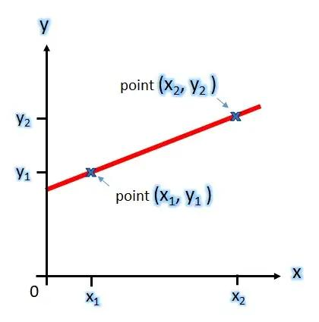
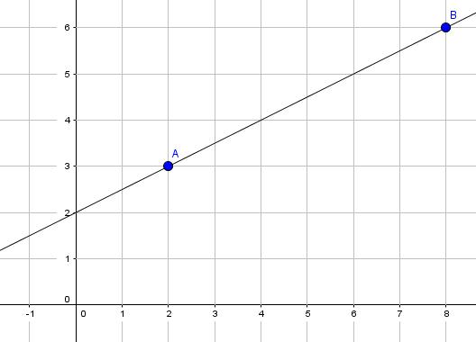
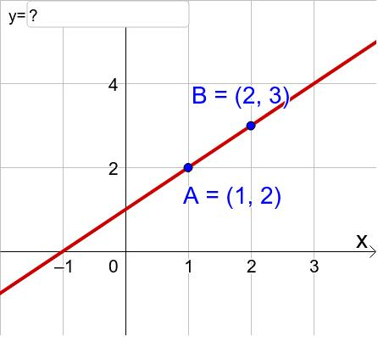
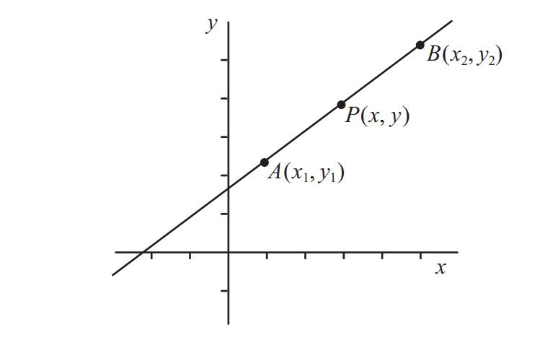
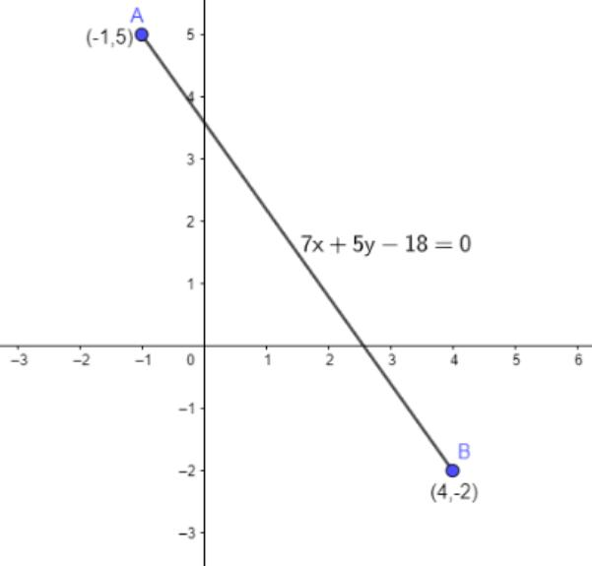

Parametric Representation
# Source: AI Source: Provided by: [Data Path: Persons Table -> ID Column: 1, Name_En Column: Motasem Essam] -> From: [ChatGPT] on [7/25/2026]
A line in two-dimensional space can be written as:
$$\vec{r}=\vec{a}+t\vec{d}$$
where:
- \vec a is a point on the line,
- \vec d is the direction vector,
- t\in\mathbb{R}.
For example:
$$\vec{r}=\left(\begin{matrix}1 \\ 2\end{matrix}\right)+t\left(\begin{matrix}2 \\ 3\end{matrix}\right)$$
When t=0:
$$P=\left(1 , 2\right)$$
When t=1:
$$P=\left(3 , 5\right)$$
When t=2:
$$P=\left(5 , 8\right)$$
All these points lie on the same line.
Thus:
$$\boxed{P\left(t\right)∈l \text{for every }t∈R}$$

Point on a Line in Three-Dimensional Space
# Source: AI Source: Provided by: [Data Path: Persons Table -> ID Column: 1, Name_En Column: Motasem Essam] -> From: [ChatGPT] on [7/25/2026]
A point can also lie on a line in \mathbb{R}^3.
A 3D line can be represented as:
$$\vec{r}=\vec{a}+t\vec{d}$$
For example:
$$\vec{r}=\left(\begin{matrix}1 \\ 2 \\ 3\end{matrix}\right)+t\left(\begin{matrix}2 \\ 1 \\ 4\end{matrix}\right)$$
At t=2:
$$\vec{r}=\left(\begin{matrix}1 \\ 2 \\ 3\end{matrix}\right)+2\left(\begin{matrix}2 \\ 1 \\ 4\end{matrix}\right) \\ =\left(\begin{matrix}5 \\ 4 \\ 11\end{matrix}\right)$$
Therefore:
$$\boxed{\left(5 , 4 , 11\right)∈l}$$
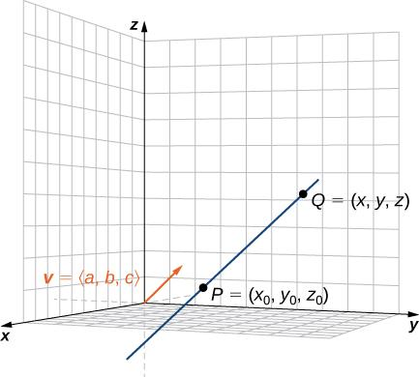
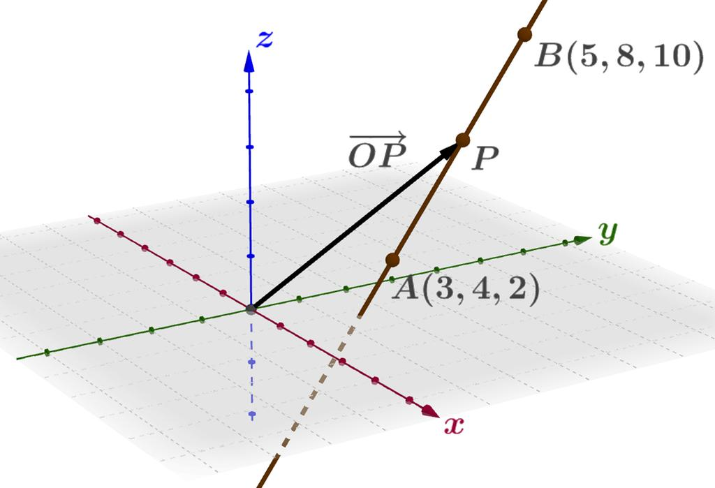
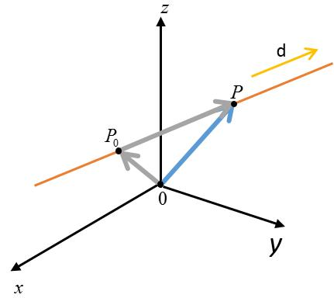
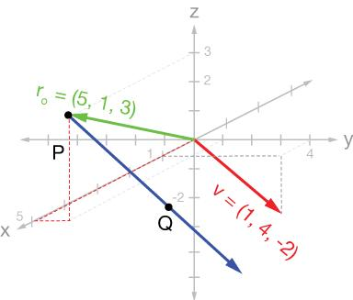
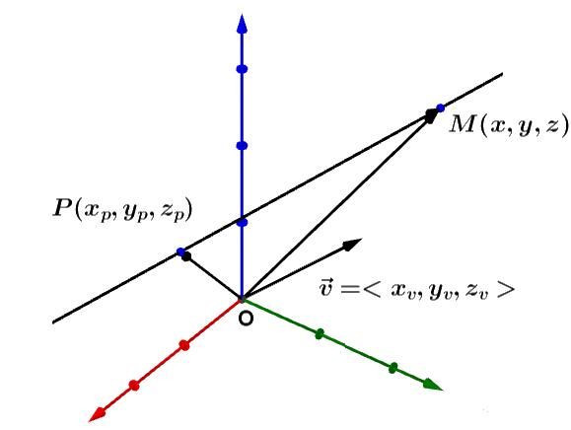

Geometric Meaning
# Source: AI Source: Provided by: [Data Path: Persons Table -> ID Column: 1, Name_En Column: Motasem Essam] -> From: [ChatGPT] on [7/25/2026]
When:
$$P∈l$$
the point and line have a containment relationship.
The point is not merely close to the line; it is exactly located on the line.
This distinction is important:
$$P∈l$$
means the point is on the line, while:
$$P∉l$$
means it is not.
A point can be arbitrarily close to a line without being contained in it.

Point on a Line vs Point Near a Line
# Source: AI Source: Provided by: [Data Path: Persons Table -> ID Column: 1, Name_En Column: Motasem Essam] -> From: [ChatGPT] on [7/25/2026]
Consider:
$$l:y=2x$$
The point:
$$P=\left(3 , 6\right)$$
satisfies:
$$6=2\left(3\right)$$
so:
$$P∈l$$
But:
$$Q=\left(3 , 6.1\right)$$
does not satisfy the equation:
$$6.1≠6$$
so:
$$Q∉l$$
Even though Q is very close to the line, it is not contained in it.

Relationship with Line Segment and Ray
# Source: AI Source: Provided by: [Data Path: Persons Table -> ID Column: 1, Name_En Column: Motasem Essam] -> From: [ChatGPT] on [7/25/2026]
A line, ray, and segment are related because they can all contain points.
Line
$$P∈\overset{↔}{AB}$$
The line extends infinitely in both directions.
Ray
$$P∈\vec{AB}$$
The ray starts at A and extends infinitely in one direction.
Segment
$$P∈\overset{‾}{AB}$$
The segment contains only the points between A and B, including the endpoints.
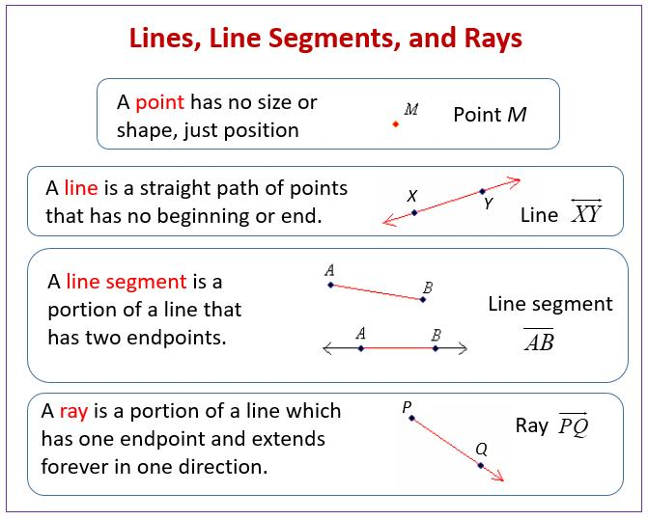
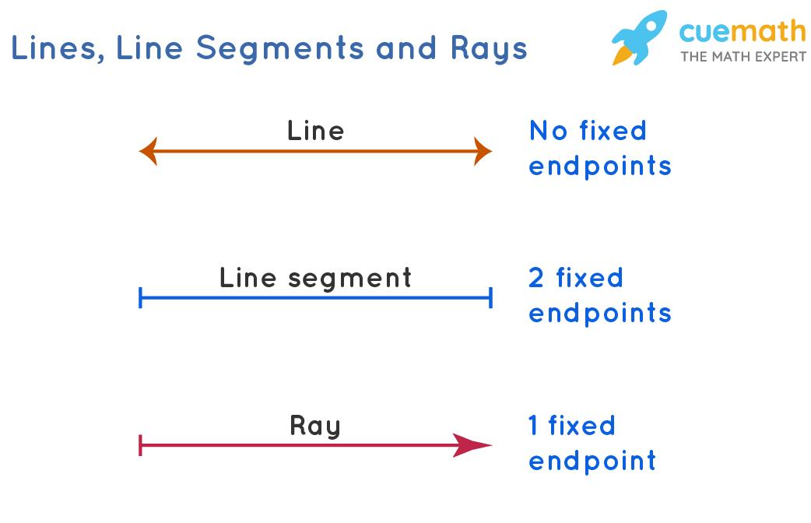
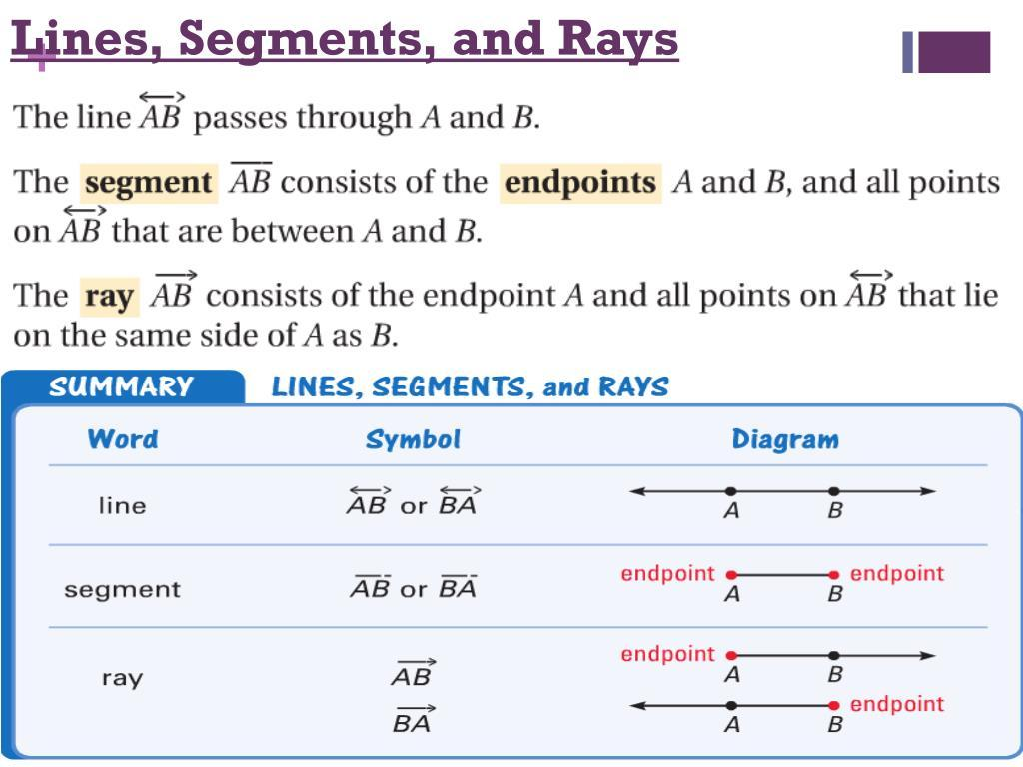

Point on a Line vs Point on a Segment
# Source: AI Source: Provided by: [Data Path: Persons Table -> ID Column: 1, Name_En Column: Motasem Essam] -> From: [ChatGPT] on [7/25/2026]
This distinction is particularly important.
Suppose:
$$A=\left(0 , 0\right)$$
and:
$$B=\left(5 , 0\right)$$
The entire x-axis contains both the segment and infinitely many additional points.
For:
$$P=\left(3 , 0\right)$$
we have:
$$P∈\overset{‾}{AB}$$
and:
$$P∈\overset{↔}{AB}$$
But for:
$$Q=\left(10 , 0\right)$$
we have:
$$Q∈\overset{↔}{AB}$$
while:
$$Q∉\overset{‾}{AB}$$
because Q lies beyond endpoint B.

Point on a Line vs Intersection
# Source: AI Source: Provided by: [Data Path: Persons Table -> ID Column: 1, Name_En Column: Motasem Essam] -> From: [ChatGPT] on [7/25/2026]
If two lines intersect at point P:
$$l_{1}∩l_{2}=\left\{P\right\}$$
then:
$$P∈l_{1}$$
and:
$$P∈l_{2}$$
Thus, point containment describes the relationship of P with each line, while intersection describes the relationship between the two lines.

Point on a Line vs Coincidence
# Source: AI Source: Provided by: [Data Path: Persons Table -> ID Column: 1, Name_En Column: Motasem Essam] -> From: [ChatGPT] on [7/25/2026]
Point containment:
$$P∈l$$
does not mean that the point and line are coincident.
Coincidence between two points is:
$$P=Q$$
while a point and a line have different geometric dimensions and are normally described using membership:
$$P∈l$$
Therefore:
$$\boxed{\text{Point on a line = containment, not coincidence}}$$

Important Properties
# Source: AI Source: Provided by: [Data Path: Persons Table -> ID Column: 1, Name_En Column: Motasem Essam] -> From: [ChatGPT] on [7/25/2026]
- A line contains infinitely many points.
- Any two distinct points determine exactly one line in Euclidean geometry.
- If two distinct points A and B lie on a line l, then:
$$A,B∈l$$
- A point either belongs to a particular line or does not.
- A point on a line has zero distance from the line:
$$\boxed{d\left(P , l\right)=0}$$
- A point not on the line has positive distance from it:
$$d\left(P , l\right)>0$$
- Point-on-line relationships occur in both 2D and 3D geometry.
- Coordinate equations provide an algebraic test for point containment.

Distance Interpretation
# Source: AI Source: Provided by: [Data Path: Persons Table -> ID Column: 1, Name_En Column: Motasem Essam] -> From: [ChatGPT] on [7/25/2026]
A point lies on a line exactly when its perpendicular distance from the line is zero.
For a line:
$$ax+by+c=0$$
the distance from:
$$P=\left(x_{0} , y_{0}\right)$$
to the line is:
$$d\left(P , l\right)=\frac{∣ax_{0}+by_{0}+c∣}{\sqrt{a^{2}+b^{2}}}$$
Therefore:
$$\boxed{P∈l ⟺ d\left(P , l\right)=0}$$
This provides another mathematical way to define point-on-line containment.

Examples

Example 1
# Source: AI Source: Provided by: [Data Path: Persons Table -> ID Column: 1, Name_En Column: Motasem Essam] -> From: [ChatGPT] on [7/25/2026]
$$l:y=4x-3 \\ P=\left(2 , 5\right)$$
Check:
$$5=4\left(2\right)-3 \\ 5=5$$
Therefore:
$$\boxed{P∈l}$$

Example 2
# Source: AI Source: Provided by: [Data Path: Persons Table -> ID Column: 1, Name_En Column: Motasem Essam] -> From: [ChatGPT] on [7/25/2026]
$$l:3x+2y=12 \\ P=\left(2 , 3\right)$$
Check:
$$3\left(2\right)+2\left(3\right)=6+6=12$$
Therefore:
$$\boxed{P∈l}$$

Example 3
# Source: AI Source: Provided by: [Data Path: Persons Table -> ID Column: 1, Name_En Column: Motasem Essam] -> From: [ChatGPT] on [7/25/2026]
$$l:3x+2y=12 \\ Q=\left(2 , 4\right)$$
Check:
$$3\left(2\right)+2\left(4\right)=6+8=14$$
Since:
$$14≠12$$
we have:
$$\boxed{Q∉l}$$

Relationship with Related Concepts
# Source: AI Source: Provided by: [Data Path: Persons Table -> ID Column: 1, Name_En Column: Motasem Essam] -> From: [ChatGPT] on [7/25/2026]
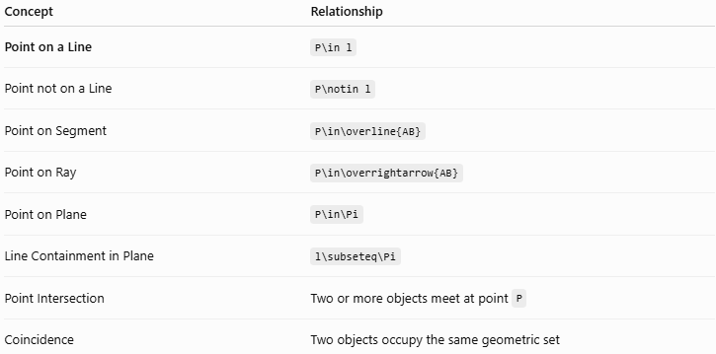
Concept | Relationship
Point on a Line | P\in l
Point not on a Line | P\notin l
Point on Segment | P\in\overline{AB}
Point on Ray | P\in\overrightarrow{AB}
Point on Plane | P\in\Pi
Line Containment in Plane | l\subseteq\Pi
Point Intersection | Two or more objects meet at point P
Coincidence | Two objects occupy the same geometric set

Real-World Applications
# Source: AI Source: Provided by: [Data Path: Persons Table -> ID Column: 1, Name_En Column: Motasem Essam] -> From: [ChatGPT] on [7/25/2026]
Point-on-line relationships are used in:
- Architecture – checking whether structural points lie on designed edges.
- Engineering – verifying alignment of components.
- CAD – determining whether vertices lie on edges or construction lines.
- Computer graphics – determining geometric relationships between vertices and edges.
- Surveying – checking whether a measured point lies on a reference line.
- Navigation – determining whether a location lies on a route.
- Robotics – checking whether a robot position lies on a planned path.

Advantages
# Source: AI Source: Provided by: [Data Path: Persons Table -> ID Column: 1, Name_En Column: Motasem Essam] -> From: [ChatGPT] on [7/25/2026]
- Simple and precise relationship.
- Easy to express mathematically.
- Can be tested directly using coordinates.
- Forms the basis for defining segments, rays, and lines.
- Fundamental to coordinate geometry.
- Useful in both theoretical and computational geometry.

Limitations
# Source: AI Source: Provided by: [Data Path: Persons Table -> ID Column: 1, Name_En Column: Motasem Essam] -> From: [ChatGPT] on [7/25/2026]
- Exact point containment assumes exact mathematical coordinates.
- In real-world measurements, tolerances and measurement errors mean a point may only be approximately on a line.
- For complicated curves or computational geometry, containment testing may require more advanced methods.

Key Points
# Source: AI Source: Provided by: [Data Path: Persons Table -> ID Column: 1, Name_En Column: Motasem Essam] -> From: [ChatGPT] on [7/25/2026]
- Point on a Line is a type of Point Containment.
- It is represented by:
$$\boxed{P∈l}$$
- A point belongs to a line when it lies exactly on the line.
- For:
$$y=mx+b$$
point (x_0,y_0) lies on the line when:
$$\boxed{y_{0}=mx_{0}+b}$$
- For:
$$ax+by=c$$
the condition is:
$$\boxed{ax_{0}+by_{0}=c}$$
- A point on a line has distance zero from that line.
- A point can belong to a line without belonging to a particular segment of that line.
- Point-on-line containment is different from line-line intersection.
- It applies in both two-dimensional and three-dimensional geometry.

Conclusion
# Source: AI Source: Provided by: [Data Path: Persons Table -> ID Column: 1, Name_En Column: Motasem Essam] -> From: [ChatGPT] on [7/25/2026]
Point on a Line describes the situation in which a point belongs exactly to a given line. It is a fundamental form of Point Containment, expressed as P\in l. In coordinate geometry, the relationship can be verified by substituting the point's coordinates into the equation of the line. Understanding point-on-line containment provides the foundation for more advanced concepts such as line segments, rays, collinearity, line intersection, coordinate geometry, and spatial geometry.

